**TR:**

cat /etc/passwd | grep -i megastar | tr '[:lower:]' '[:upper:]'

cat /etc/passwd | grep -i megastar | tr '[:upper:]' '[:lower:]' | tr ':' '-'

- It cannot find a whole string and edit it whole or part of it.

- It works at individual character level rather than sentence level.

- Add text before or after a line/sentence.

**Using SED:**

Sed works at line level in a file where tr works at character level.

Replace abc with power in all line only first occurrence:

**abc**101:x:1018:1018::/home/**abc**101:/bin/bash - This line has two occurrences in a single line.

cat /etc/passwd | sed 's/abc/power/1g' /etc/passwd

power101:x:1018:1018::/home/abc101:/bin/bash

Replacing abc with power from a line range:

Belore command will replace abc to power in 2nd occurrence for all lines between 55 to 58

cat /etc/passwd | sed '55,58 s/abc/power/2g' /etc/passwd

sed -i '/^Sub*/i #ADDING LINE BEFORE MATCH' /tmp/sshd_config

sed -i '/^Sub*/a #ADDING LINE AFTER MATCH' /tmp/sshd_config

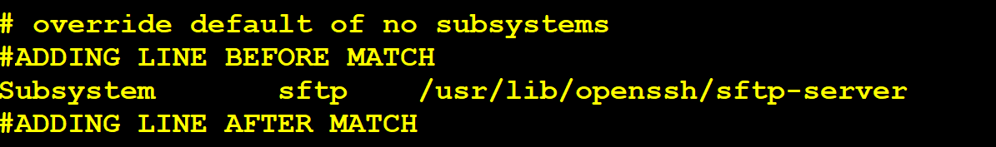

Changing password authentication to yes on line number 58:

sed -i "58 s/.*PasswordAuthentication.*/PasswordAuthentication yes/g" /etc/ssh/sshd_config

Dry-Run:

sed "58 s/.*PasswordAuthentication.*/PasswordAuthentication yes/g" /etc/ssh/sshd_config | grep -i PasswordAuthentication